Public Key Infrastructure(PKI) Lab

NAME: JASHWANTH REDDY GANGULA

SUID: 646254141

1 Lab Overview

Even though public key encryption forms the core of secure communication, it is subject to main in the middle attacks. (MITM). The attacker can intercept the traffic between Alice and Bob. When Bob sends the encrypted secret key to Alice using public key Encryption, he will intercept it, get the key and will send his own public key to Alice. Once he knows the key now, he can see the traffic between them. So to solve this problem, we introduce the concept of PKI.  
PKI helps the Alice to trust the owner of public key.

At the end of this Lab, we will gain better understanding of how PKI works, how it is used to protect the web, and how MITM attacks can be defeated.

2 Lab Tasks

2.1 Task 1: Becoming a Certificate Authority (CA)

A CA acts a trusted entity for issuing digital certificates. The digital certificate certifies the ownership of a public key by a named subject i.e., owner. In this lab, we will create digital certificates by becoming root ourselves and then act as CA to issue certificates to other servers. Generally, CAs are signed by another trusted CA’s and this goes on until we reach root CA’s which are self-certified. Root CAs are generally loaded onto Operating systems or browsers and are unconditionally trusted.

We copy the /usr/lib/ssl/openssl.cnf file to the local directory. If we inspect the configuration file under [CA_default] section as shown below, we need to create the folders demoCA and then create folders certs, crl, newcrts and files index.txt and serial.

dir = ./demoCA # Where everything is kept

certs = $dir/certs # Where the issued certs are kept

crl_dir = $dir/crl # Where the issued crl are kept

new_certs_dir = $dir/newcerts # default place for new certs.

database = $dir/index.txt # database index file.

serial = $dir/serial # The current serial number

We need to add some single number in string format in serial file.

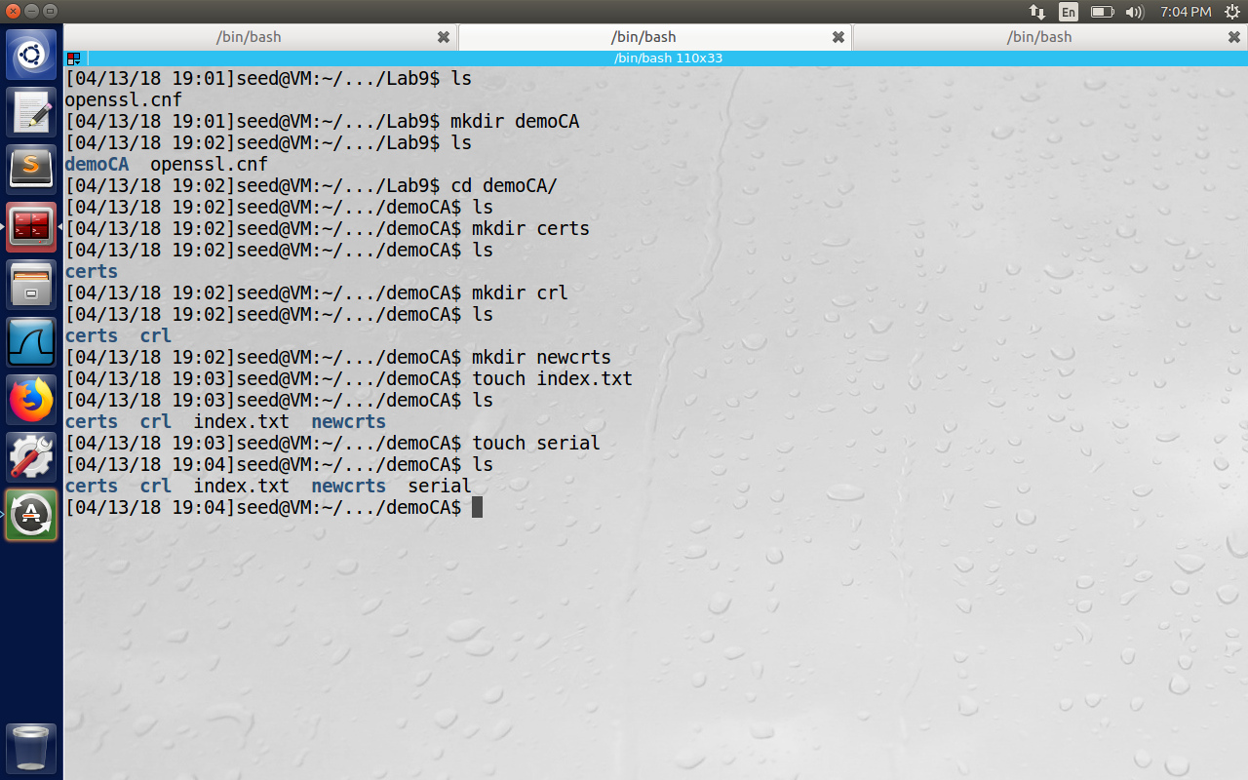

openssl expects an ANSI file, so use the command “echo 1000 > demoCA/serial”. Otherwise while generating the certificate, we will get an error saying unable to load serial number, asn1 encoding routines, a2i_ASN1_INTEGER:short line:f_int.c:212:

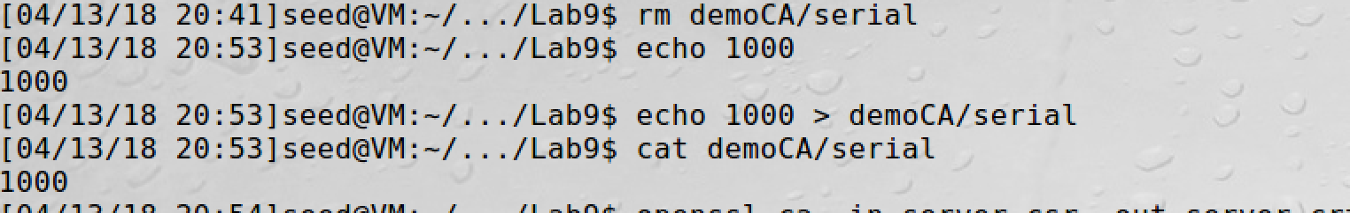

Certificate Authority(CA):  
We need to generate a self-signed certificate for our CA, i.e., then we can totally trust this and use its certificate as root certificate. We issue the command: “openssl req -new -x509 -keyout ca.key -out ca.crt -config openssl.cnf”. First time, we are asked to enter a pass phrase, common Name, Country Name etc. A passphrase is a word or phrase that protects private key files.

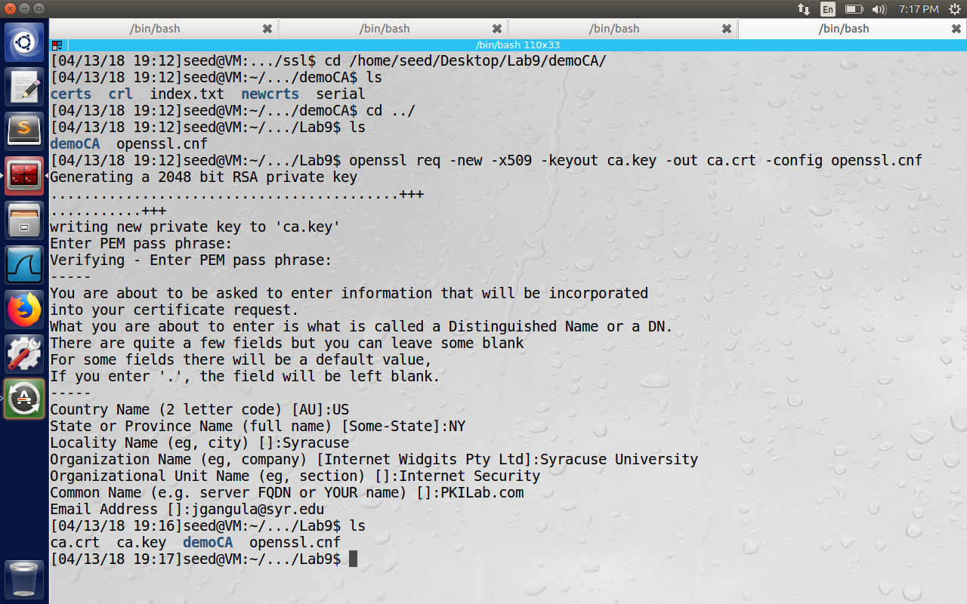

We observe that we have created two files after executing the command. One is ca.key and ca.crt, ca.key contains CA’s private key while ca.crt contains public-key certificate.

2.2 Task 2: Creating a Certificate for SEEDPKILab2018.com

Now we became root CA and are ready to sign digital certificates for our customers. Our first customer is a company called SEEDPKILab2018.com . For this company to get digital certificate from CA, it needs to go through below steps.

Step 1: Generate public/private key pair

The company needs to generate its own public/private key pair.

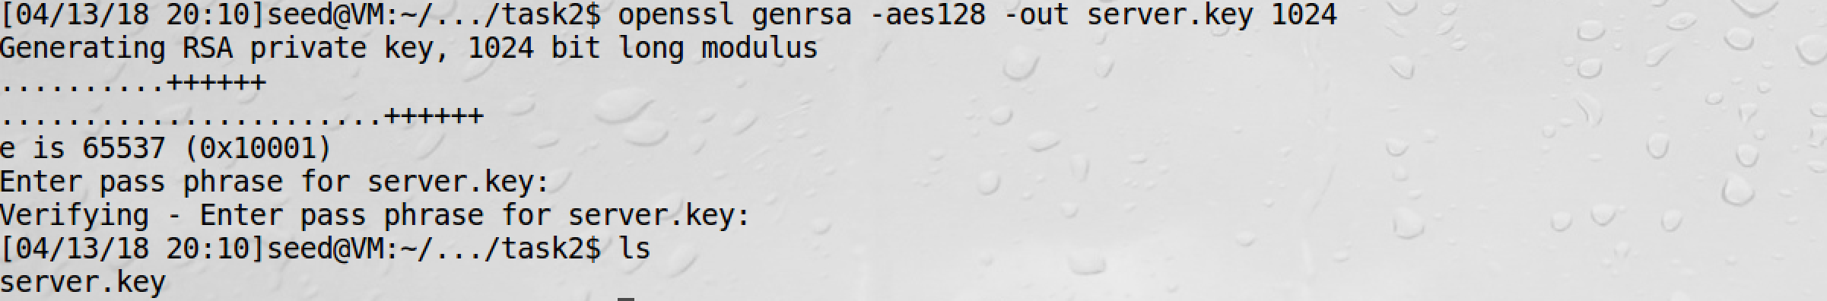

To view the contents of the encrypted private file, we need to issue the below command.

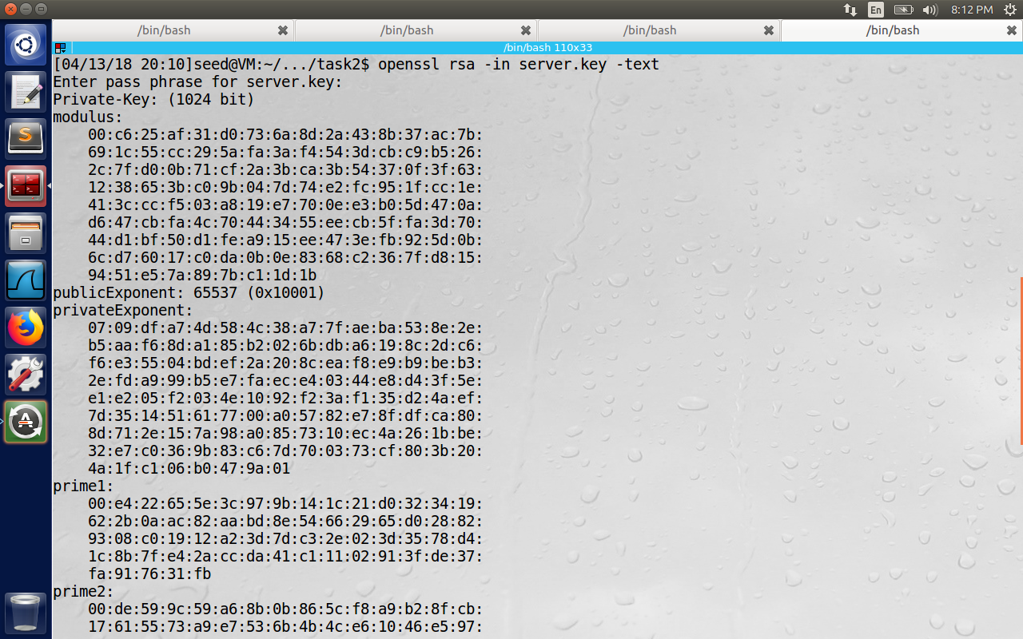

Step 2: Generate a Certificate Signing Request (CSR)

Once the company has the key file, it generates the Certificate Signing Request(CSR), which basically includes company’s public key. The CSR will be sent to CA who will generate a certificate for the key.

The below command is similar to previous step except the option –x509(which indicates self-generation of certificate without sending the request to CA). Please observe the Common Name of the certification request as SEEDPKILab2018.com

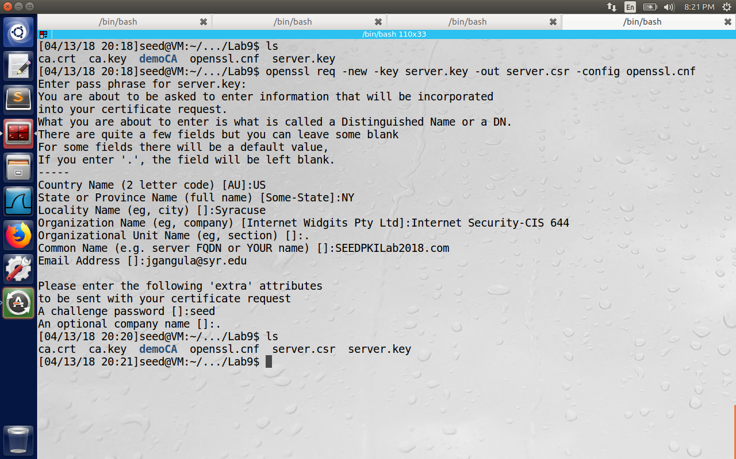

Step 3: Generating Certificates

We have generated server.csr file in the previous step. We need to add CA’s signature to this file to make it a valid certificate. In real world csr file is sent to the trusted CA for signature. In this lab, we will use our own trusted CA to generate certificates. The below command turns server.csr request to a server.crt using ca.crt and ca.key

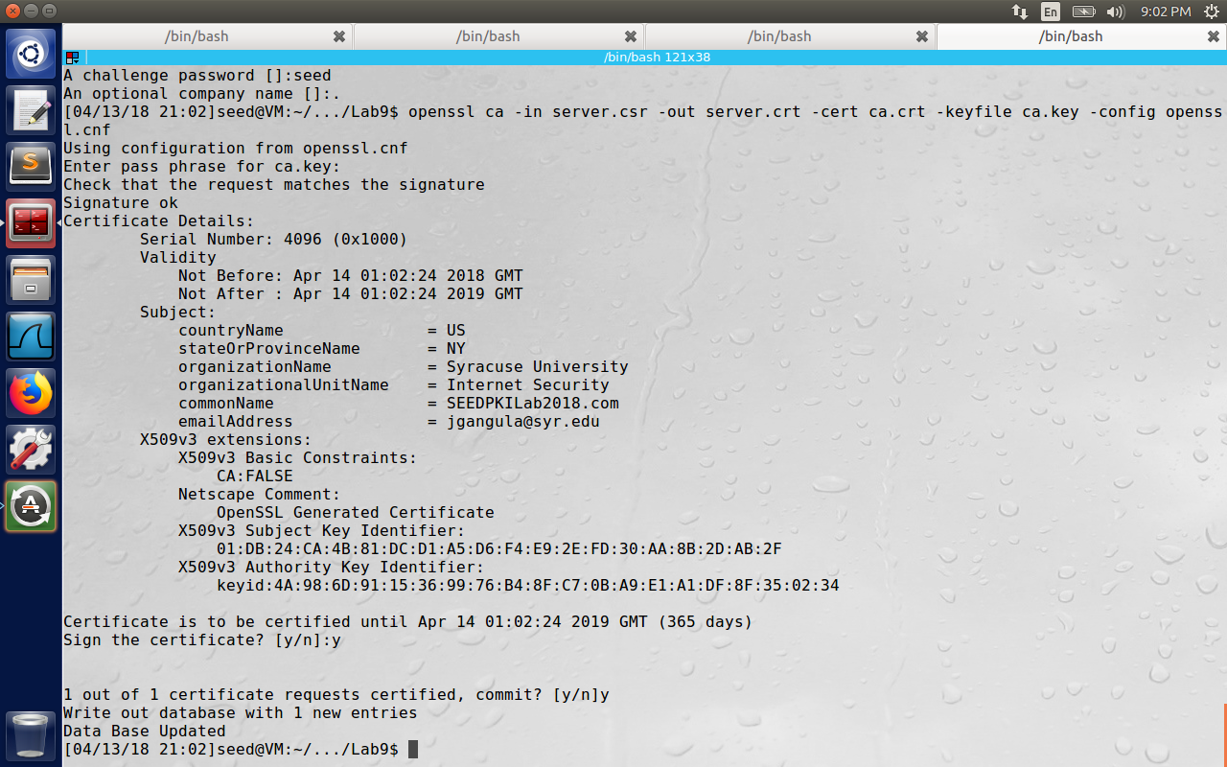

2.3 Task 3: Deploying Certificate in an HTTPS Web Server

In this task, we will explore how public-key certificates are used by websites for secure browsing. We will setup a HTTPS website using openssl’s built in web server.

Step 1: Configuring DNS

We chose SEEDPKILab2018.com as out hostname. To let the computer, recognize this host name, we add it to the /etc/hosts file. (Observe the last line below)  
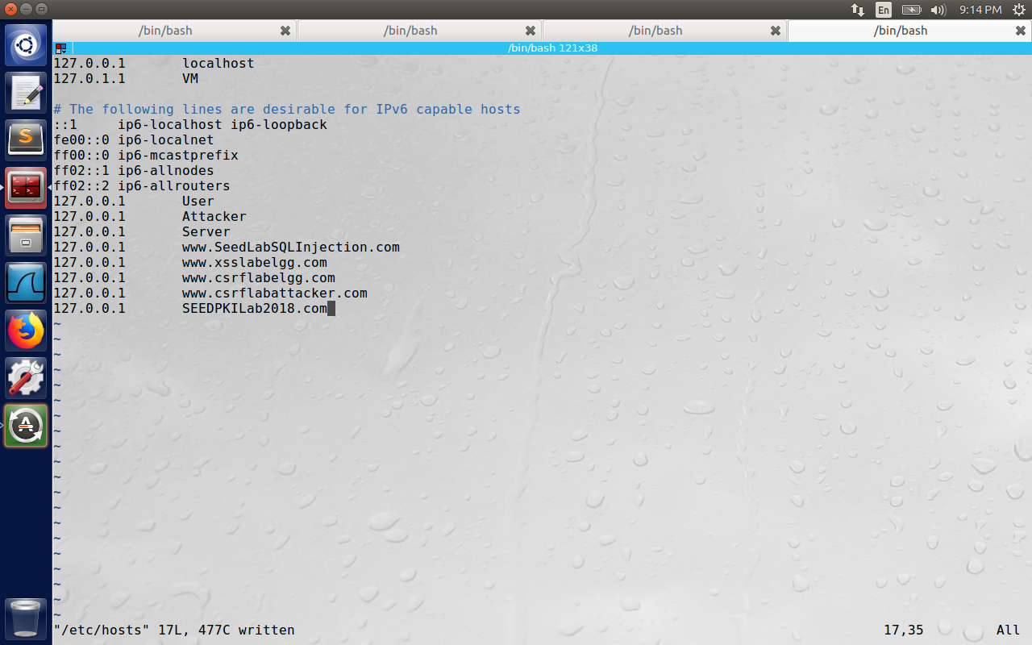

Step 2: Configuring the web server

We will use openssl to start a simple web server, using the certificate generated in the previous task.

# Combine the secret key and certificate into one file

# Launch the web server using server.pem

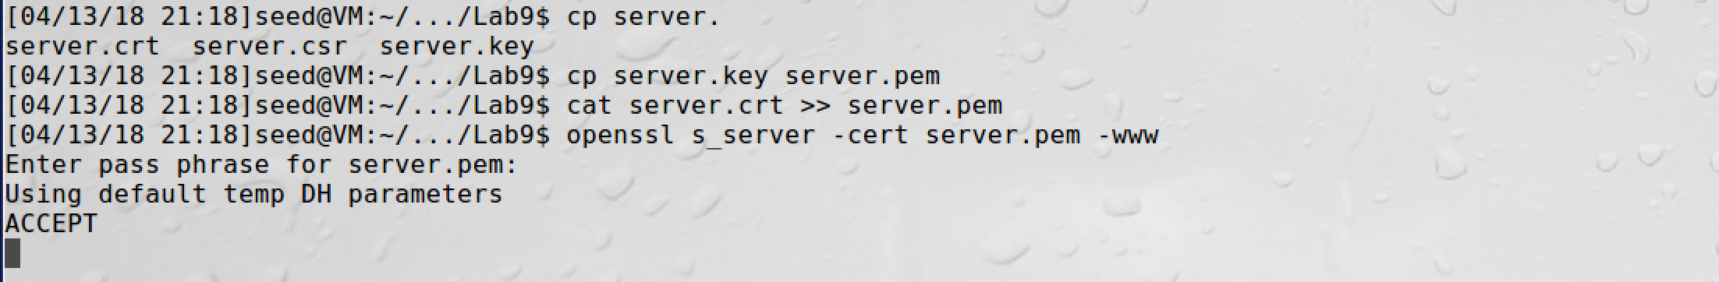

When we try to open the url: <https://seedpkilab2018.com:4433> we get the below error saying The certificate is not trusted because the issued certificate is not known.

l

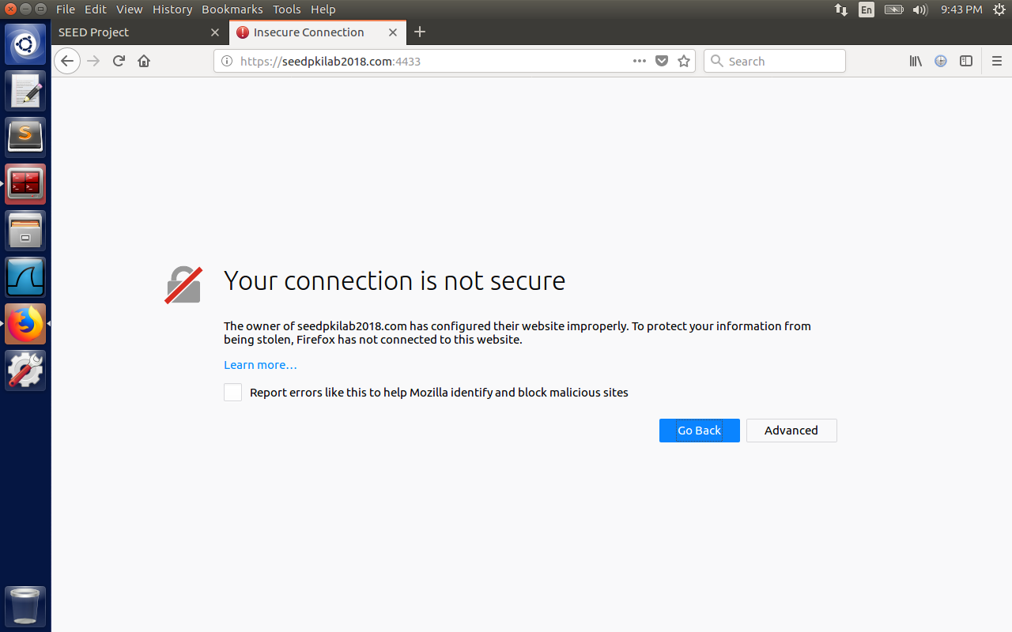

Step 3: Getting the browser to accept our CA certificate

If the certificate was issued by Verisign, then there will no such error message, because it might be preloaded into Firefox browser, but the certificate is signed by our own CA. We can either

1)Request Mozilla to include our CA’s certificate in its Firefox software, but our CA needs large enough market share in Mozilla for that, so we will manually add it to Firefox browser using

Edit->Preference->View Certificates and Import certificate and select the option, “Trust this CA to identify websites”

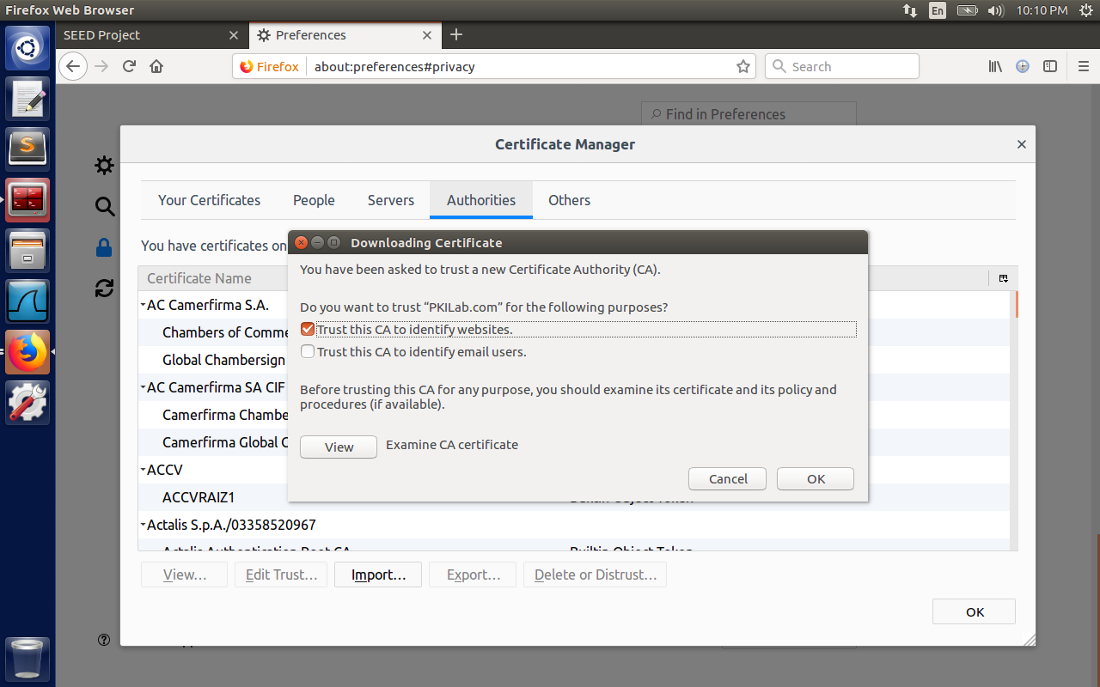

After addition,

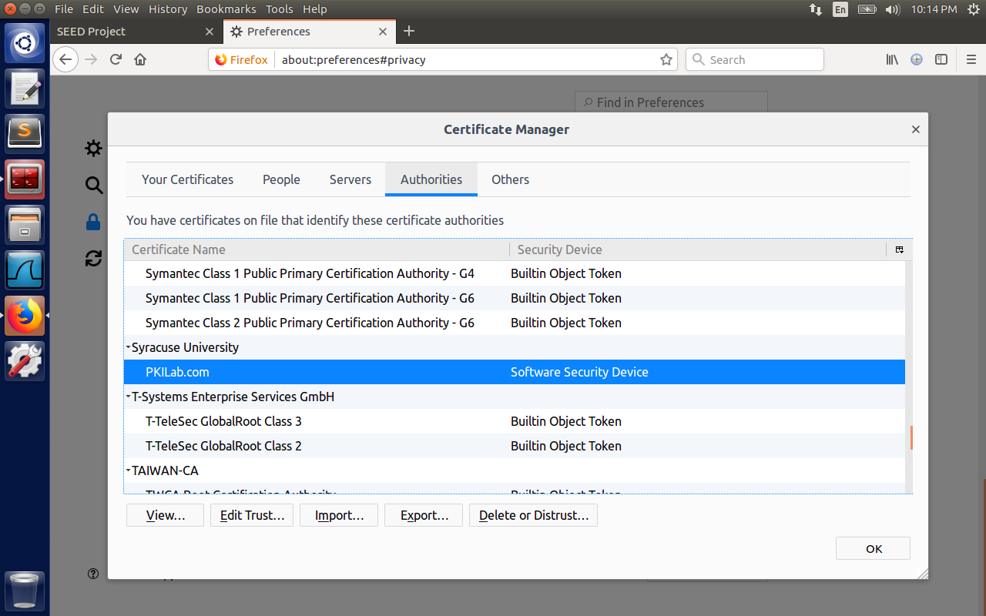

Step 4. Testing our HTTPS website

Now, point the browser to https://SEEDPKILab2018.com: 4433

The figure lists all the ciphers supported by server. Each Cipher has TLS type, encryption type details

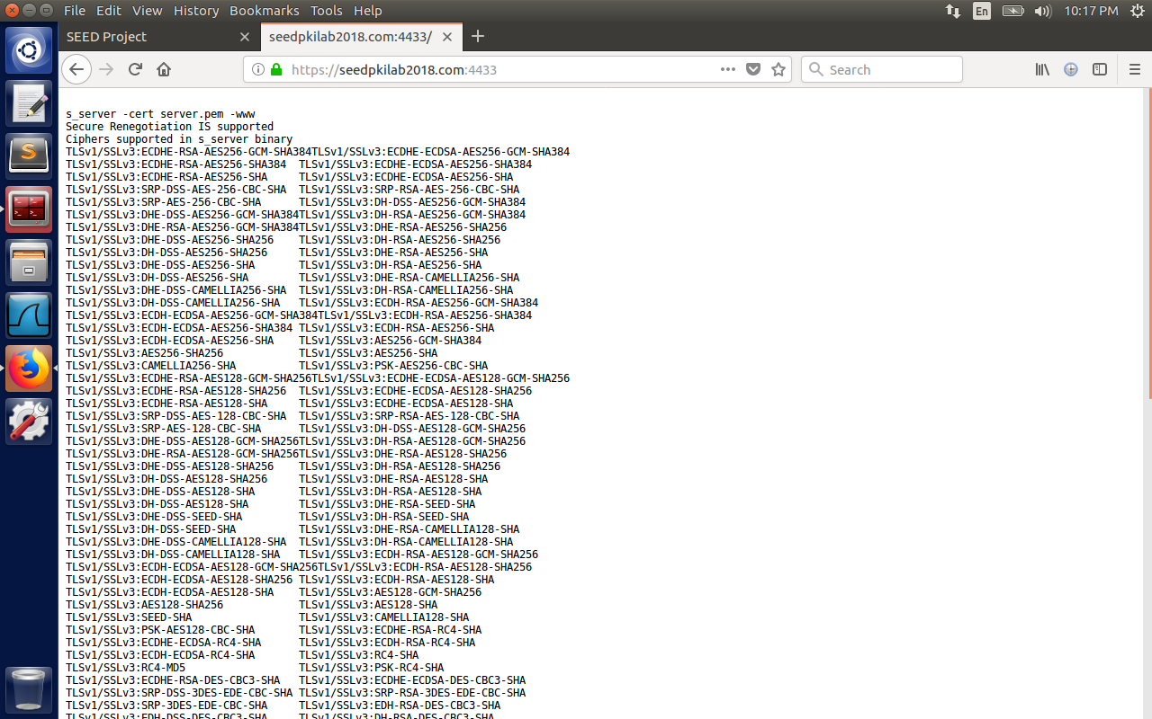

1.Modify a single byte of server.pem, and restart the server, and reload the URL. What do you observe? Make sure you restore the original server.pem afterward. Note: the server may not be able to restart if certain places of server.pem is corrupted; in that case, choose another place to modify

The browser is able to connect successfully even after modifying some byte in server.pem file, because the actual content is between BEGIN and END certificate. All the other fields we see are translated by the openssl for our human readability. Hence changing them has no effect on the https website.

2. Since SEEDPKILab2018.com points to the localhost, if we use https://localhost:4433 instead, we will be connecting to the same web server. Please do so, describe and explain your observations.

The browser was throwing error saying it uses invalid certiciate. May be if the common names are different, the browser stops the page (i.e., localhost != seedpkilab2018.com common name)

2.4 Task 4: Deploying Certificate in an Apache-Based HTTPS Website

In the previous task, we setup https server using “openssl s_server” command. This was just for debugging and demonstration purposes. In this task, we will setup a real HTTPS server based on Apache. To create a HTTPS server, we need to configure Apache to tell it where to fetch the private keys and certificates. Apache can host multiple websites simultaneously,

To add HTTPS website, we add the virtual Host entry to the file /etc/apache2/sites-available/default-ssl.conf file with the below content. We need to provide the servername, document root, create an index.html inside it, also provide the path server key and certificate.

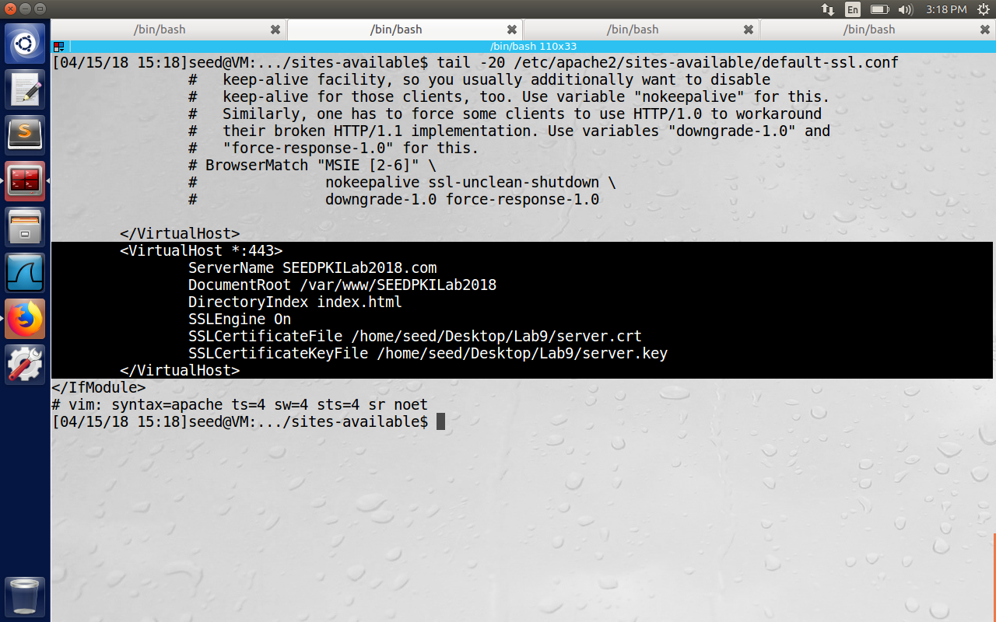

Now we need to run a series of commands to enable ssl.

1)Test the Apache configuration file for errors

$ sudo apachectl configtest

2) Enable the SSL module  
 $ sudo a2enmod ssl

3) Enable the site we have just edited

$ sudo a2ensite default-ssl  
4) Restart Apache

$ sudo service apache2 restart

The below image shows the all the commands successfully executed and create the index.html file.

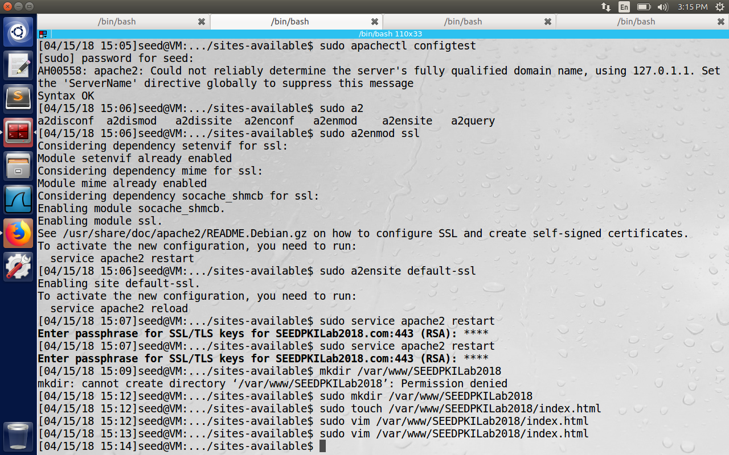

Finally, the browser was able to display the content of the index.html which is the default page for the seedpkilab2018.com

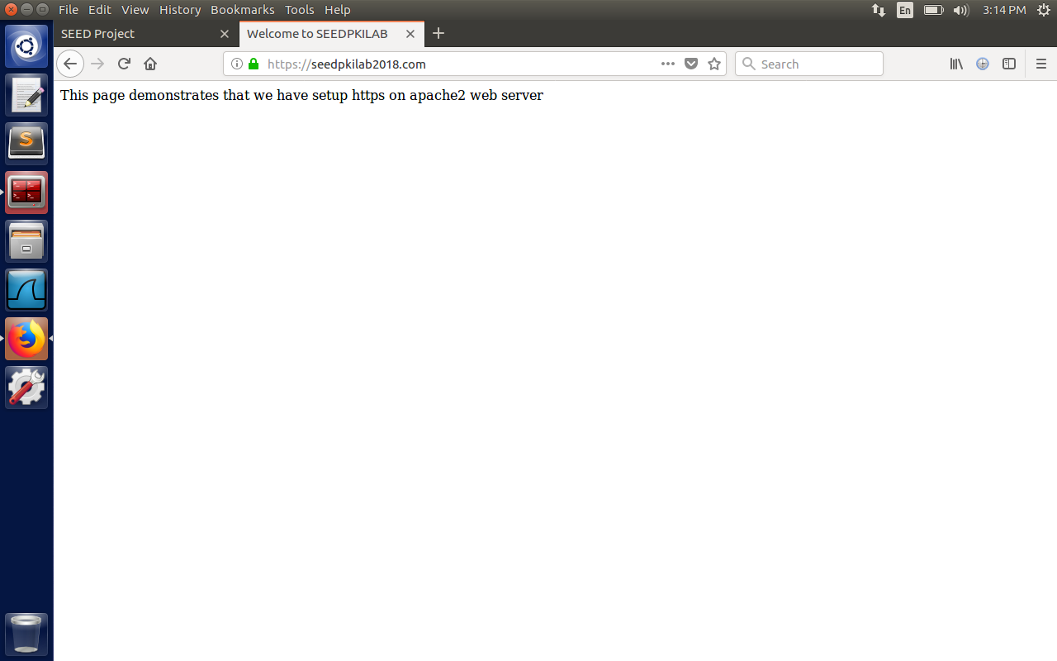

2.5 Task 5: Launching a Man-In-The-Middle Attack

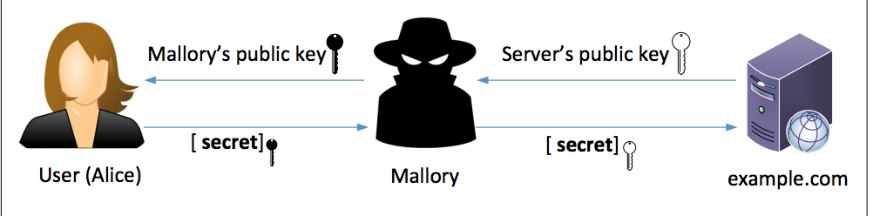

In the above figure, Alice wants to visit the example.com. The example.com will generate private and public key and sends the public key to Alice, Now Alice generates secret key, encrypts it using the public key and sends the encrypted key to the server. Now the server decrypts the secret key using private key, hence the secret key is known between Alice and server, and the communication is secure. But there is a problem with the described communication. Assume Attacker intercepts the traffic between Alice and example.com server. Now he gets the public key from example.com, and he sends his known public key to Alice instead of server’s public key. Now Alice encrypts the secret key using Attacker’s public key, when he gets the encrypted key, he can decrypt and get the secret key. And then encrypts the secret key again using server’s public key and sends it to the server. After this step, he can understand all the traffic between Alice and example.com. To solve this problem, we have concept of PKI. Alice trusts that public key owner is actually the example.com server using trusted third party CA’s.

In this task, we will show how PKI defeats the MITM attack. We will use chasebank.com as the target website. We will follow same steps as in the previous task, except the server name is chasebank.com.

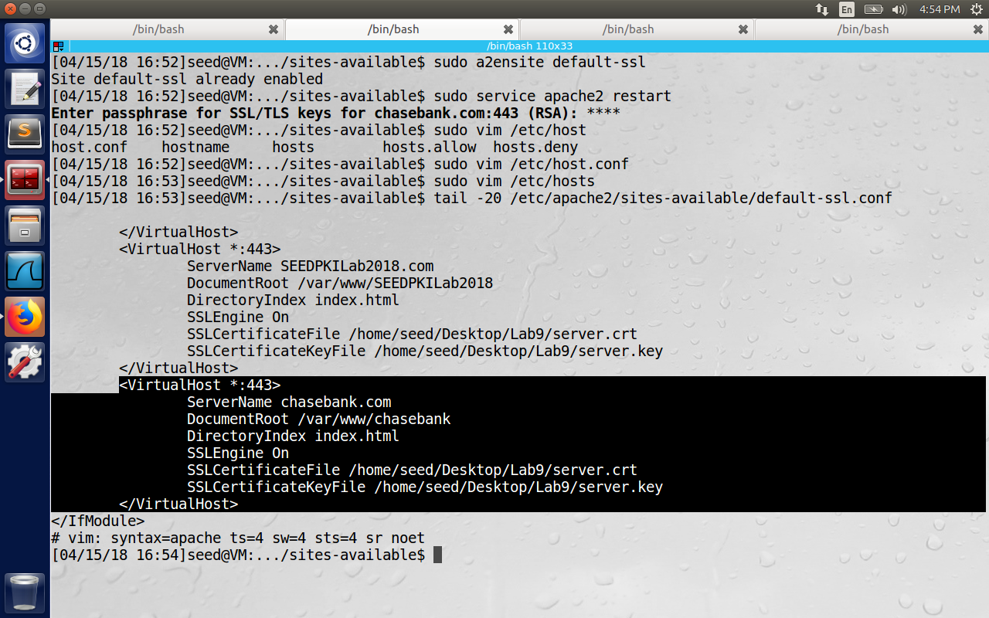

All the configuration is same as in the above figure except the server name which is chasebank.com. Now the goal is when the user tries to login to chasebank.com, we have to redirect him to our server, which is seedpkilab.com. If we make the login page look identical to the chasebank.com, user will enter his credentials, essentially disclosing them to the attacker.

Step 2: Becoming the man in the middle

We can route the user’s https requests to our web server, or we can poison victim’s DNS cache so that when he tries to find the IP address of chasebank.com, it gets the address of seedpkilab2018.com. In this lab, we simplify this by modifying the /etc/hosts file i.e, we add an entry with <IP address of malicious server> chasebank.com.

The browser has not connected to this website, because the server key contains the subject name as SEEDPKILab2018.com which can be verified using the signature of CA, but we are interested in the domain chasebank.com which is different from seedpkilab2018.com. Hence MITM is not successful, even if the DNS attack is successful.

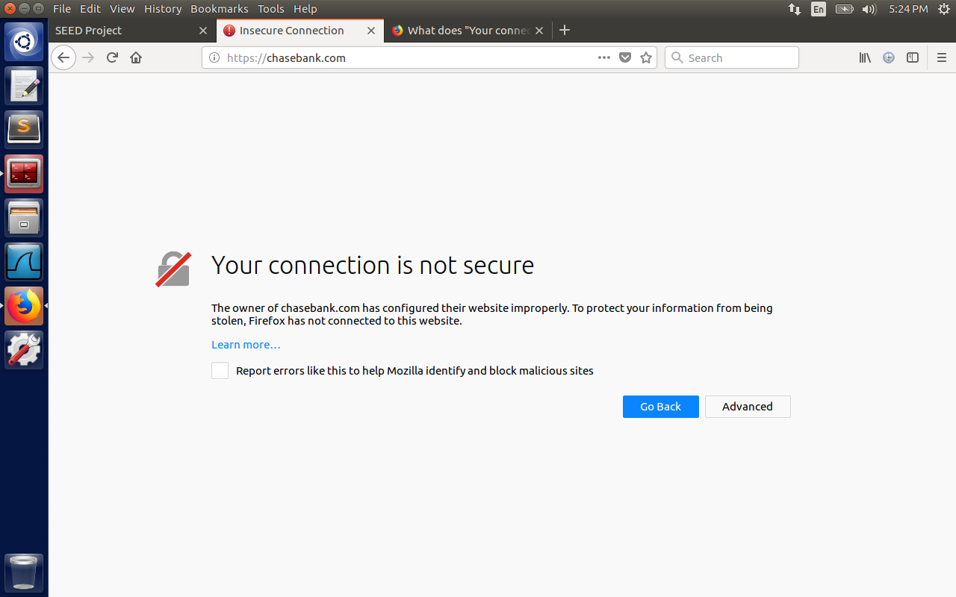

2.6 Task 6: Launching a Man-In-The-Middle Attack with a Compromised CA

First we generate key for chasebank,

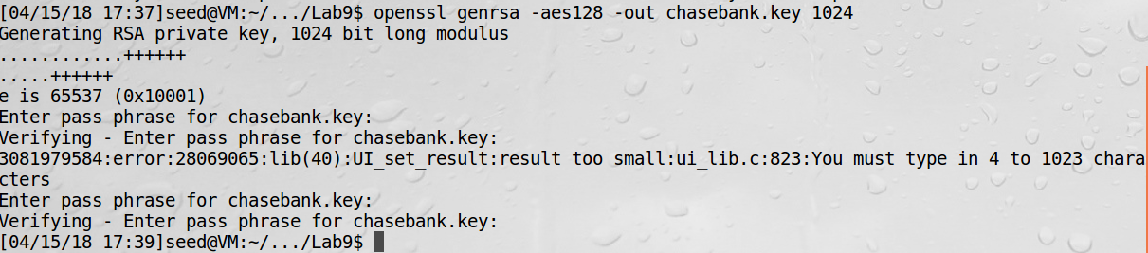

Now we generate csr file to get certified by the stolen ca.key file.

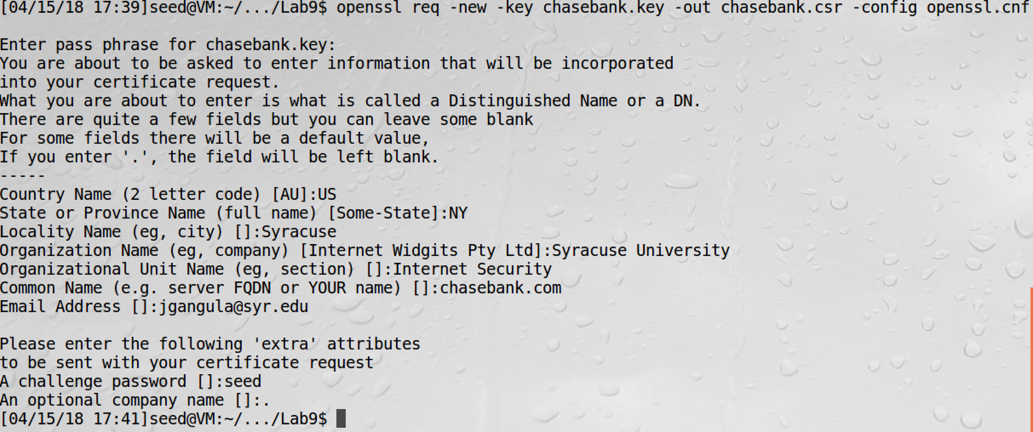

Now we sign the csr file to generate chasebank.crt file

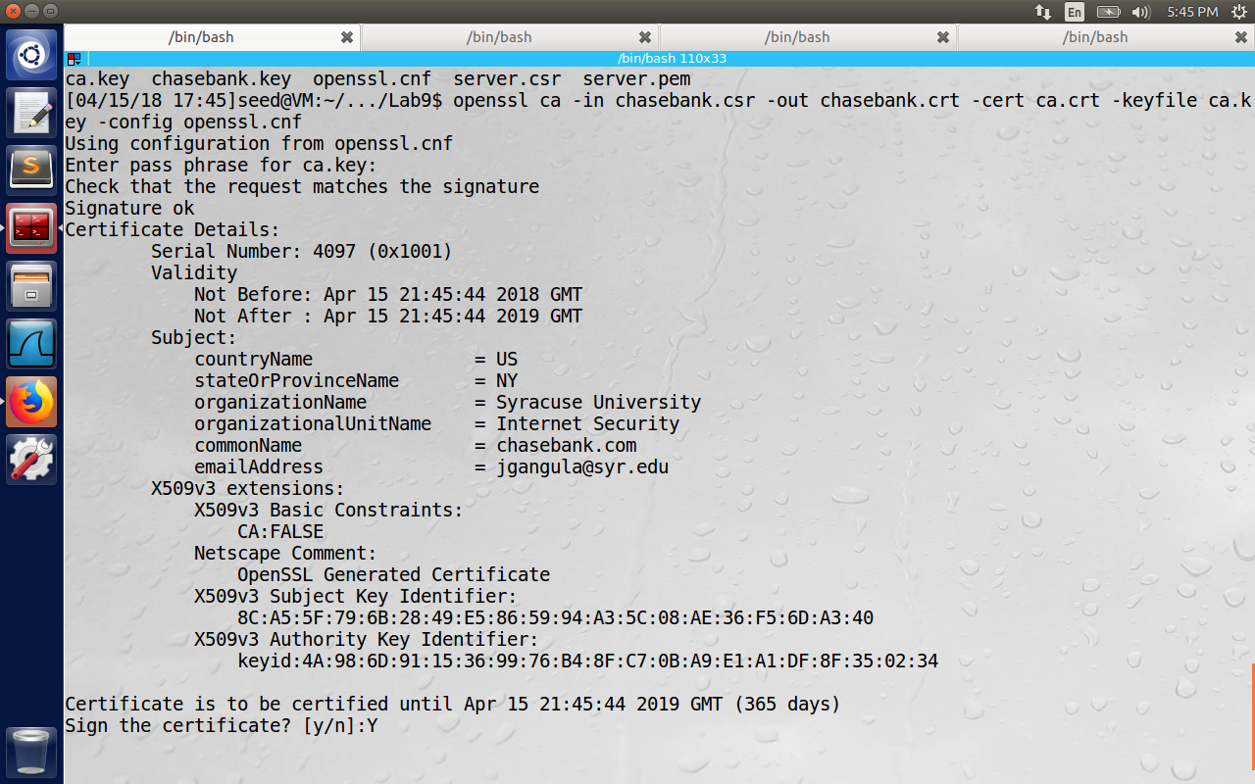

Now the attacker has generated certificate file because we have assumed that ca.key file is stolen, hence the security of browser can be compromised. 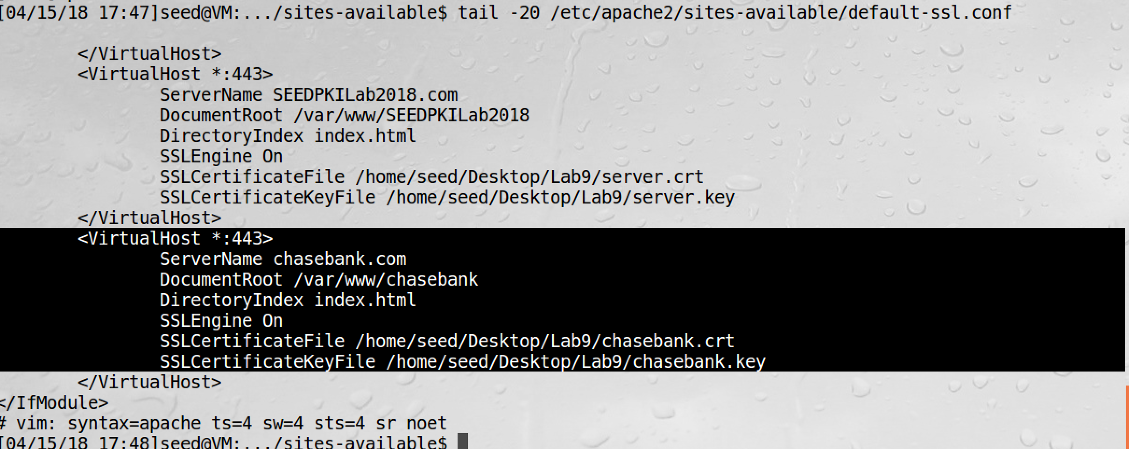

I have now demonstrated that MITM attack is successful.

